# CS 340 Animal Shelter README

## About the Project/Project Title

*The project title is Animal Shelter. The function of the project is to Create, Read, Update, and Delete data from an Animal Shelter database. The project is using Mongo DB and Python.*

## Motivation

*This project will help interact with a non-SQL database in an easy and efficient manner. Querying a database using the Animal Shelter program streamlines use of a Mongo database without having to understand the scripting language used for Mongo Database. The functionality of the project is repeatable and scalable.*

## Getting Started

*To initiate this project, you must import the data via aac_shelter_outcome.csv into the database using mongoimport command as shown below:*

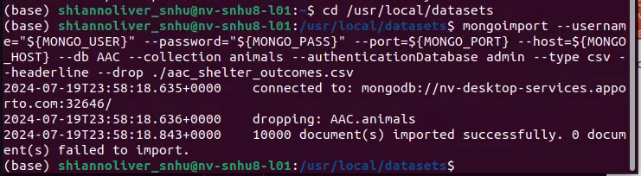

*To access the database, you must be authenticated using the correct username and password, here is an example for creating a username and password:*

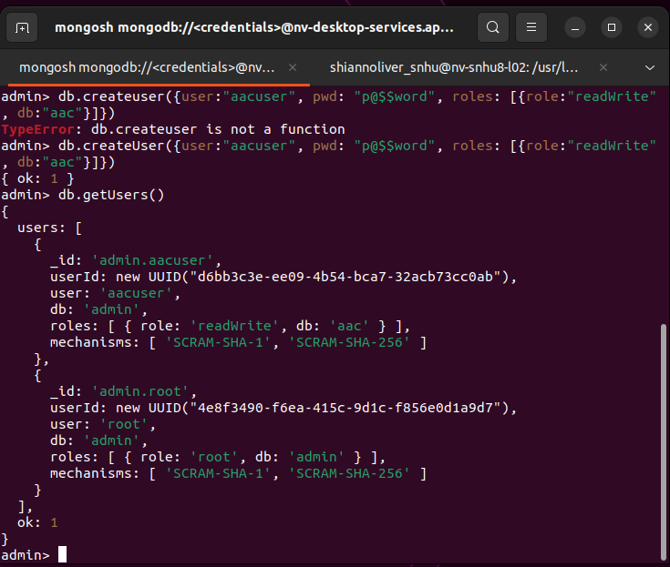

*And then you can login using that login info to test your new credentials:*

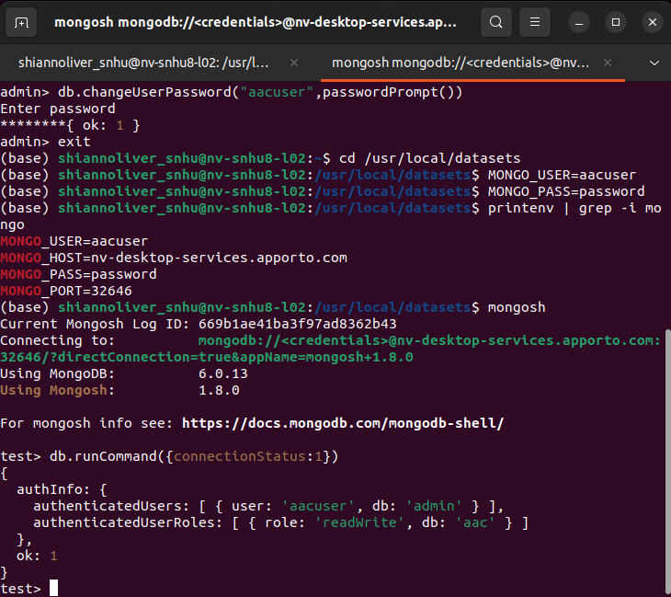

*You can then run the Python code included in this GitHub repo through Jupyter Notebook to access the database and make changes within the database.*

*To create the dashboard, please use the dashboard code contained in the github file to connect to the database:*

[*shiolive/CS-340 (github.com)*](https://github.com/shiolive/CS-340)

**Functionality**

*The dashboard uses the Dash framework to create a dashboard representation of the database. It has interactive functionality that allows users to filter, sort, view chart reports, and view a map location of specific animal records. The chart can filter by type of rescue dog needed based on Grazioso Salvares needs and the pie chart included can filter based on the requirements of those animals including breed, age, and outcome type. The following shows how they can be used to filter data:*

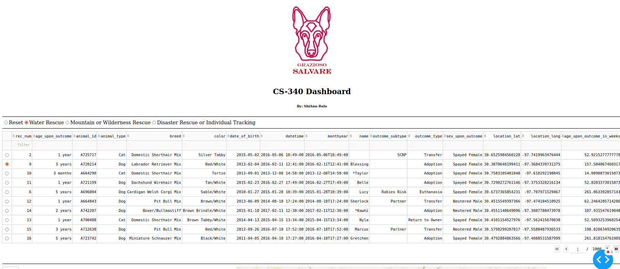

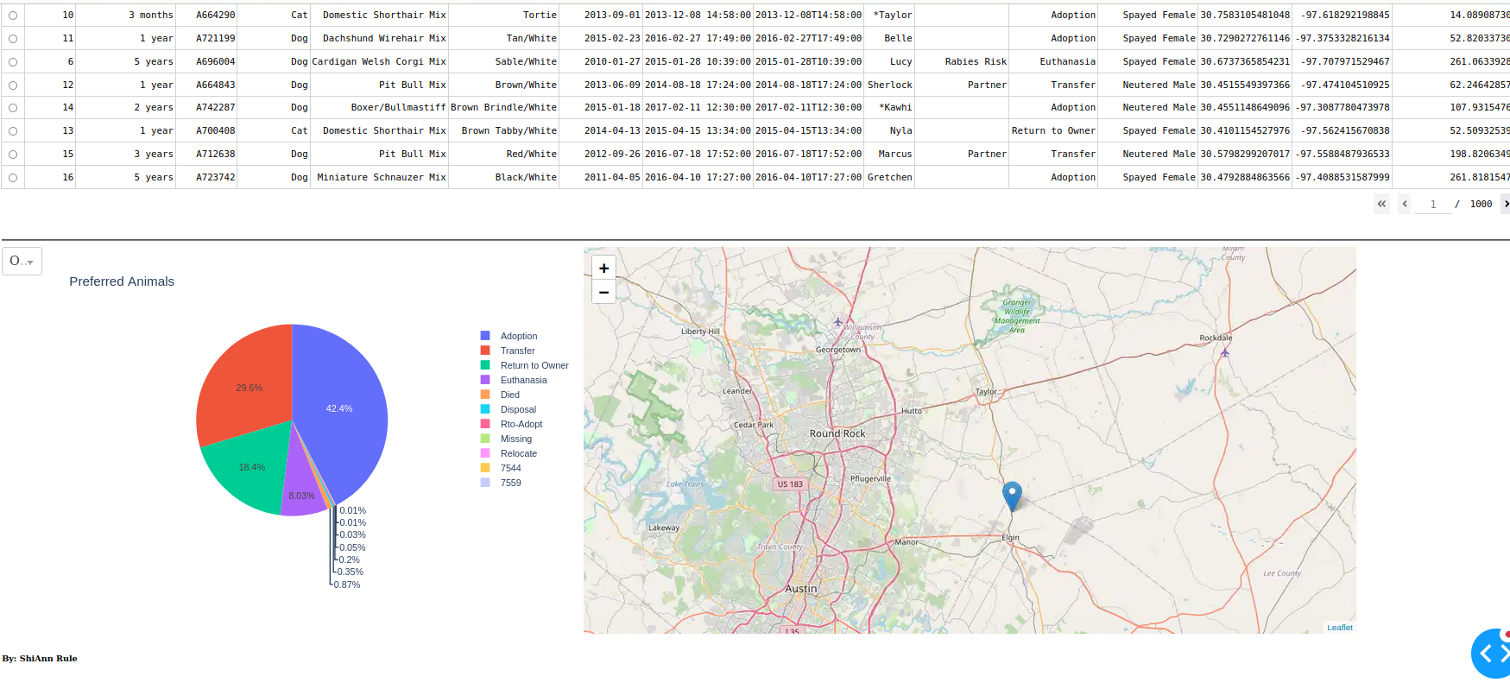

## Installation

*You will need the following tools and minimum versions:*

*Python 3.9*

*Pymongo 6.0*

*MongoDB 6.0*

## Usage

*This code allows the user to create, read, update, and delete data from the database as well as test the functionality of this code when implementing the program.*

### Code Example:

from pymongo import MongoClient

from bson.objectid import ObjectId

class AnimalShelter(object):

def __init__(self):

self.USER = 'aacuser'

self.PASS = 'password'

self.HOST = 'nv-desktop-services.apporto.com'

self.PORT = 32646

self.DB = 'AAC'

self.COL = 'animals'

self.client = MongoClient('mongodb://%s:%s@%s:%d' % (self.USER,self.PASS,self.HOST,self.PORT))

self.database = self.client['%s' % (self.DB)]

self.collection = self.database['%s' % (self.COL)]

def create(self, data):

if data is not None:

self.database.animals.insert(data)

return True

else:

raise Exception("Nothing to save, data parameter is empty")

return False

def read(self, query):

if query is not None:

data = self.database.animals.find(query, {"_id": False})

for document in data:

print(document)

else:

data = self.database.animals.find( {}, {"_id": False})

return data

#return dataset else error

def update(self, searchData, updateData):

if searchData is not None:

result = self.database.animals.update_many(searchData, { "$set": updateData })

else:

return "{}"

return result.raw_result

#update record specified, if error then return blank

def delete(self, deleteData):

if deleteData is not None:

result = self.database.animals.delete_many(deleteData)

else:

return "{}"

return result.raw_result

#delete data record specified, else return error

### Test cases

*An example of testing the results of creating a record within Jupyter:*

Create:

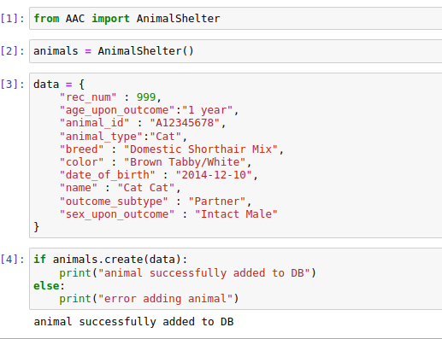

Read:

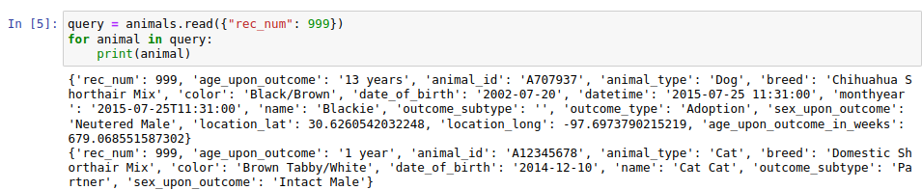Update:

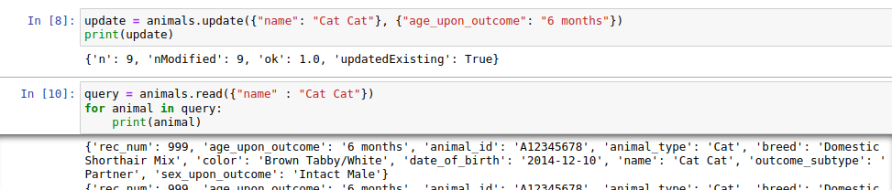Delete:

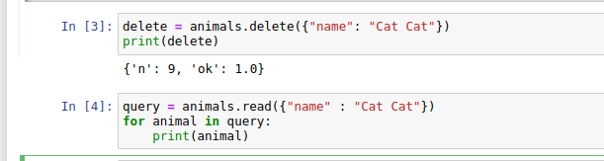

## Roadmap/Features

*Ongoing improvements are being created and will be rolled out upon completion and thorough testing. These include:*

*More querying commands, including Update and Delete, as well as others.*

*Option to have more than one user, as the current user is hard coded into the program. It should be able to be passed through constructor when initializing.*

## Contact

Your name: ShiAnn Rule

Created for SNHU